**Task 1: Comparative Research**

### 1. Image Quality

* **Midjourney** consistently delivers **highly detailed**, **photorealistic**, and **cinematic** images — with rich textures, mood, and depth. It particularly shines in fantasy, editorial, and stylized visuals
* **DALL·E 3** produces **clean**, **versatile**, and **prompt-accurate** images with strong realism, although sometimes less dramatic than Midjourney's.

### 2. Prompt Accuracy

* **DALL·E 3** is praised for **literal prompt-following** — it's more likely to honor every element you request.
* **Midjourney** is more interpretative, sometimes creatively deviating from the literal prompt. However, it's also capable of richly layered storytelling via imagery.

### 3. Style Flexibility

* **Midjourney** is exceptionally flexible in style: you can tune **artistic flair**, **level of abstraction**, or emotional tone. Tools like **Vary (Region)**, **Style Reference**, and **Character Reference** offer advanced controls.
* **DALL·E 3** supports multiple styles, concept blending, and **outpainting** to extend images beyond boundaries.

### 4. Usability

* **DALL·E 3**, integrated into ChatGPT (via ChatGPT Plus) and Bing Image Creator, offers a **simple, conversational interface** with minimal learning curve.
* **Midjourney** operates primarily through **Discord commands**, requiring users to learn specific formatting and experience some complexity, though web interface exists.

### 5. Licensing & Terms

* **DALL·E 3** grants users ownership and commercial use of generated images, though OpenAI may retain reuse rights unless on enterprise tiers.
* **Midjourney** also allows commercial use, but images are **publicly visible by default**, unless you subscribe to Pro/Mega plans with “Stealth Mode.” Legal concerns exist due to lawsuits over alleged unauthorized use of copyrighted images.

IMAGE OF DALL.E IMAGE OF MIDJOURNEY

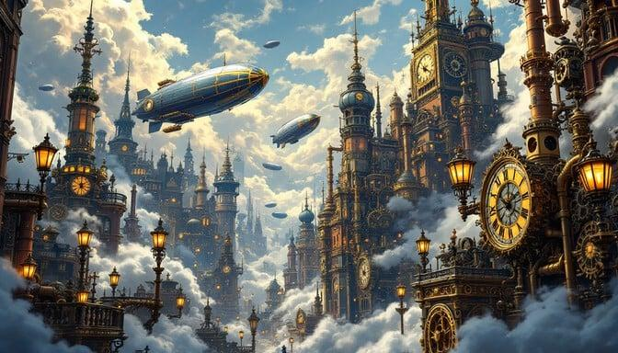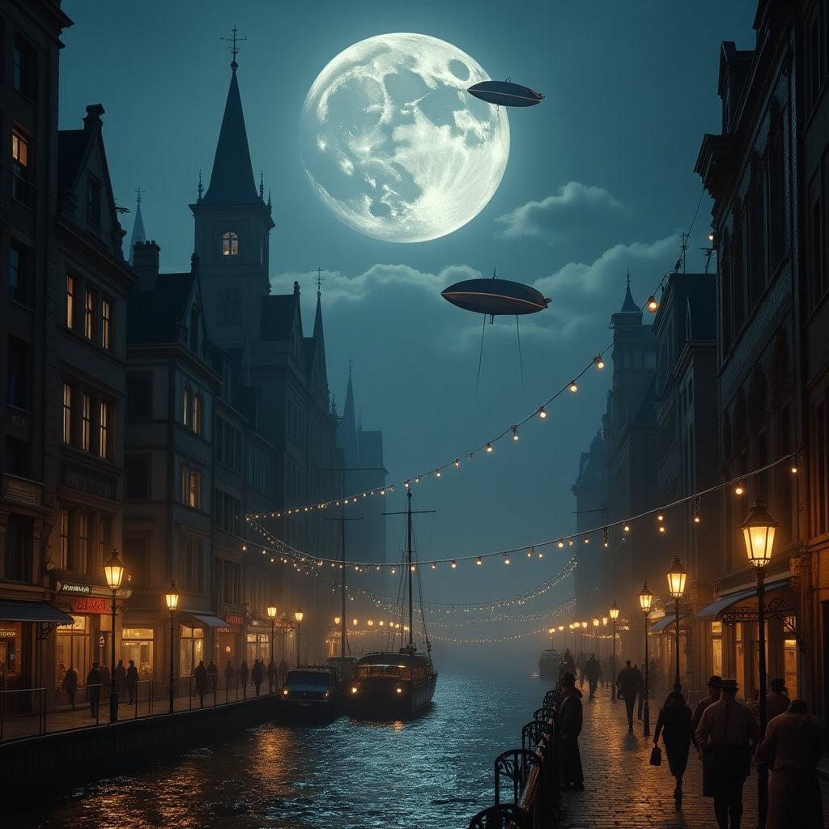

**Task 2: Visual Design Project**

